Access to our own "private" cluster and 1TB-Drive @ PSI

Access
@ the SLS we now have two private clusters for reconstruction and a 1TB-drive “in the cloud” which is only accessible by us.
Login to this drive is now possible via the gateway of the PSI
ssh haberthuer@balrog.psi.ch
ssh slslc05.psi.ch
and then the drive should be accessible at
/afs/psi.ch/user/h/haberthuer/slsbl/x02da-fs-data3/e11126/Data3/e11126
If not, then use blmount to mount it with
blmount x02da-fs-data3 e11126
If you're at the beamline and want to mount the drive with Samba (Windows or OS X), use
\\x02da-fs-data3\e11126
This only works cleanly, if you've also mounted the “normal” directory
\\x02da\e11126
using
blmount x02da e11126

Reconstructions
To actually get into the beamline, you have to use the x02da-gateway as follows
ssh haberthuer@balrog.psi.ch
ssh haberthuer@slslc05.psi.ch
ssh haberthuer@xo02da-gw
ssh e11126@x02da-cons-X (substituting 2, 4, etc. for X)
and then you're at the beamline.
Start Firefox with issuing
firefox &
in the terminal. Go to http://x02da-reco-1/beta_py/ to work with the RecoManager as when you would be at the beamline.
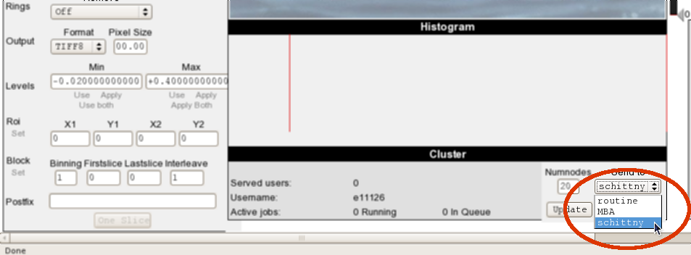
Our cluster is called “schittny”. In recent (beta-)versions of the RecoManager we can just select this cluster for reconstructions (see image on the right). If we want to submit reconstructions with the script (~/www/reco/cvs/Python/tif2rec_batch_interface.py), this cluster also exists, adapt the call accordingly.
If we want to use the conventional tif2rec_batch_web_grid*.py scripts, for example for 360°-reconstructions, we have to change how the servers are called. This includes Fedes custom-made /work/sls/bin/tif2rec_batch_web_grid_cn_david.py-skript for gridrec!!!
Use the following commands in the terminal of a beamline-console to change the routine-server-calls to our servers:
cd /usr/local/cluster/DiCoClient
rm servers.txt
ln -fs servers_schittny.txt servers.txt
ll # lists all the files and shows the links. it should show "servers.txt -> servers_schittny.txt"
cd - # goes back to the directory you've been before
tif2rec_batch_web_grid*.py <parameters>
ln -fs makes a symbolic link (ln -fs source destination) from our preferences to the ones that are called. This also means that one has to reset the preferences to normal when everything is done. This is achieved with issuing the following commands:
cd /usr/local/cluster/DiCoClient
rm servers.txt
ln -fs servers_routine.txt servers.txt
ll
cd -

